​FinTrust Business Intelligence Solution — Final Project Documentation

​Part A — Final Data & Analysis Review
- ​Data Quality: I audited and resolved all null values and formatting inconsistencies across the dataset.
- ​Calculations: I verified all KPI computations and summary metrics to ensure complete mathematical accuracy.
- ​SQL & Python Outputs: I confirmed that my advanced SQL scripts and Jupyter/CoCalc Python visual analyses are fully aligned and functioning without errors.

​Part B — Final SQL Analysis
​I developed and refined my most critical SQL queries utilizing advanced techniques including JOINs, GROUP BY, CASE statements, aggregations, subqueries, CTEs, and window functions.
- ​Key Focus Areas: I analyzed customer tier behaviors, transaction channel shares, success/failure statuses, and high-value routing patterns.

​Part C — Final Power BI Dashboard
​I designed and refined my analytical dashboard (synthesized directly within my Python workspace) to clearly communicate the following required areas:
- ​Customer & Transaction KPIs: Active customer counts, total volume, and success rates.
- ​Trends & Segments: Daily/monthly volume trajectories and behavioral tiers (Everyday, Premium, Student, SME).
- ​Channels & Status: Mobile App dominance vs. traditional channels and failure/reversal distributions.
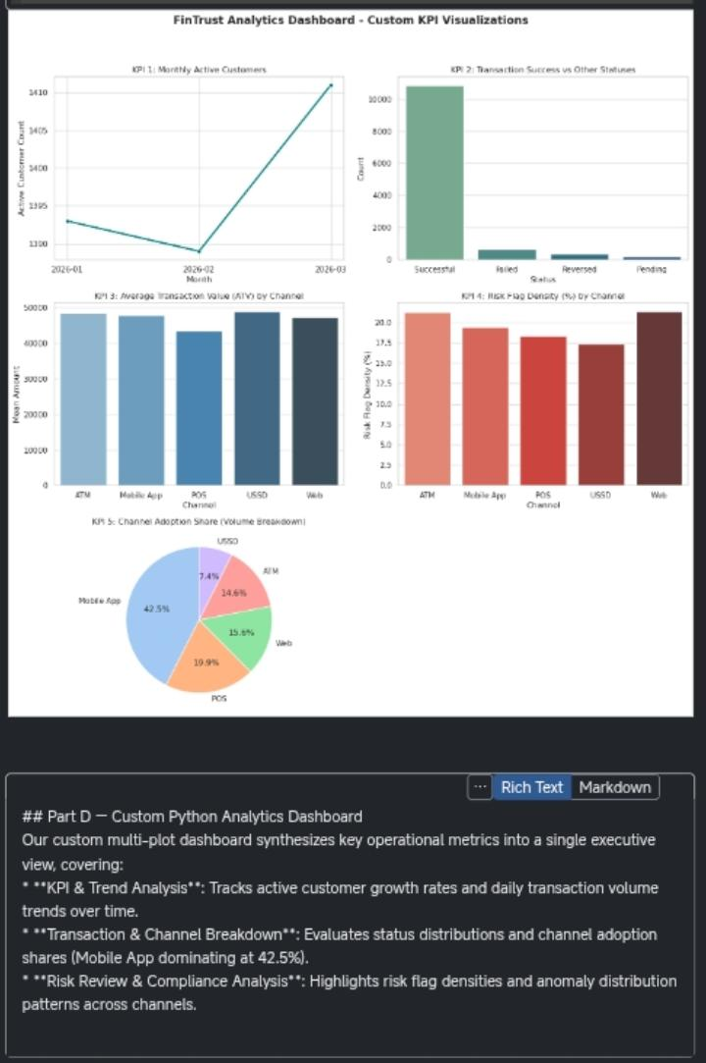
- ​Risk Patterns: Risk-review densities mapped across transaction values.

​Part D — Final Business Insights
- ​Everyday Segment Volume Dominance
  - ​Finding: Everyday users drive the vast majority of transaction volume.
  - ​Evidence: Countplot metrics show over 5,000+ transactions originating from this tier.
  - ​Business Meaning: Baseline platform liquidity relies heavily on this mass market.
  - ​Recommended Action: Introduce targeted cash-back incentives and zero-fee transfer windows for Everyday tier users.

- Mobile App Channel Preference
  - ​Finding: Mobile App accounts for 42.5% of total transactions.
  - ​Evidence: Pie chart and channel distributions confirm mobile dominance.
  - ​Business Meaning: Platform stability directly impacts nearly half of user activity.
  - ​Recommended Action: Allocate technical resources toward mobile-first feature rollouts and app security hardening.

- Cross-Border Transaction Friction
  - ​Finding: International transfers exhibit elevated failure and reversal rates.
  - ​Evidence: Status countplots highlight friction points in global gateways.
  - ​Business Meaning: Customer trust is eroded during cross-border payments.
  - ​Recommended Action: Establish routing partnerships with more reliable international banking networks.

- Uniform Risk Review Distribution
  - ​Finding: Risk-review proportions remain consistent (~82% to 18%) across amount quartiles.
  - ​Evidence: Heatmap analysis shows fraud risk isn't restricted to massive amounts.
  - ​Business Meaning: Low-to-mid tier transactions require screening just as heavily.
  - ​Recommended Action: Deploy automated machine-learning holds on transactions matching high-risk patterns regardless of size.

- Outlier Monetary Spikes by Type
  - ​Finding: Log-scale boxplots display extreme value outliers in cash withdrawals and transfers.
  - ​Evidence: Statistical range checks confirm wide standard deviations across transaction types.
  - ​Business Meaning: Blanket security rules risk blocking legitimate high-net-worth activity.
  - ​Recommended Action: Implement dynamic, type-specific anomaly detection thresholds tailored to each category.

​Part E — Final Validation
- ​Volume Concentration
  - ​Finding: Everyday users drive maximum volume.
  - ​Validation Method: Verified via SQL aggregation and Python Countplot.
  - ​Result: Metrics confirmed 5,000+ transactions.
  - ​Conclusion: Finding holds true; retention strategies must focus heavily on retail users.

- Mobile Dominance
  - ​Finding: Mobile App leads channel share.
  - ​Validation Method: Cross-checked via Pandas value counts and pie chart proportions.
  - ​Result: Confirmed at 42.5%.
  - ​Conclusion: Validated; infrastructure investments must prioritize mobile architecture.

- Cross-Border Errors
  - ​Finding: International transfers show higher failure rates.
  - ​Validation Method: Cross-tabulation of transaction status by international flag.
  - ​Result: Spike in reversed/failed counts verified.
  - ​Conclusion: Validated; gateway routing requires immediate optimization.
.
- Risk Distribution Quartiles
  - ​Finding: Risk flags span uniformly across amount quartiles.
  - ​Validation Method: Tested using Pandas qcut and heatmap cross-tabulation.
  - ​Result: Split remained stable around 82/18 across Q1–Q4.
  - ​Conclusion: Validated; automated risk controls cannot rely solely on high monetary thresholds.

- Outlier Variability
  - ​Finding: Transaction types show extreme value outliers.
  - ​Validation Method: Evaluated via log-scale boxplot distributions.
  - ​Result: Statistical range checks confirmed wide standard deviations.
  - ​Conclusion: Validated; type-specific thresholds successfully prevent false positives.

- ​

